Reema Baby
Table 1
Question | Artwork 1 | Artwork 2
Subjects | The artwork shows repeated images of actress Marily Monroe. It explores fame, celebrity culture, and how people are represented in the media. | The artworks showa Jesus Christ and his disciples during the last supper before his crucifixion
Medium | Silkscreen printing with acrylic paint on canvas. | Tempera and oil paint on plaster.
Elements and Principles of Design | The repeated images create rhythm and unity. The bright colors and contrast between colorful and black and white sections catch attention. | The use of perspective, balance, and lines leading toward Jesus creates focus. The expressions and gestures of the figures create emotion.
Year and Place | 1962 New York | Around 1495 - 1498 Milan, Italy
Social, political or spiritual ideas | Represents the rise of mass media, consumer culture, and how celebrities became modern symbols. It shows how society views fame and popular culture. | Represents Christian beliefs and the importance of religion in Renaissance Europe. It shows a spiritual story from the Bible.
Moral values represented | Shows ideas about identity, fame, and how society can value images and appearances. | Represents faith, loyalty, sacrifice, and the importance of spiritual beliefs.
Insert Image here | 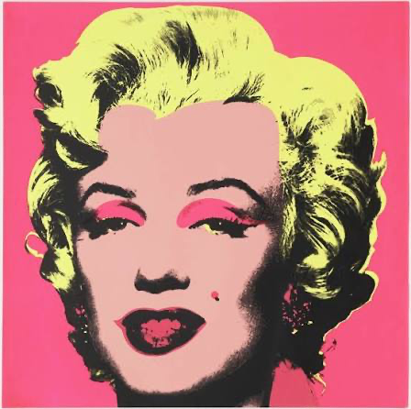 | 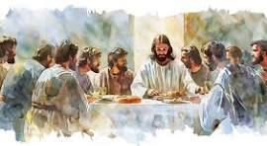

Table 2
Question | Artwork 1 | Artwork 2
Subjects | Shows Campbell’s soup cans, an everyday product representing consumer culture and popular culture. | Show a small human figure representing fertility, life, and survival.
Medium | Synthetic polymer paint and silkscreen ink on canvas. | Limestone sculpture.
Elements and Principles of Design | Uses bright colors, repetition, balance, and unity. | Uses texture, rounded shapes, and emphasis on the human form.
Year and Place | Created in 1962 in the U.S | Created around 28,000 - 25,000 BCE in prehistoric Europe; discovered in Austria.
Social, political or spiritual ideas | Represents advertising, mass production, and American consumer culture. | Represents prehistoric beliefs about fertility, survival, and human life.
Moral values represented | Shows how everyday products can become part of culture and society. | Represents life, family, survival, and human existence.
Insert Image here | 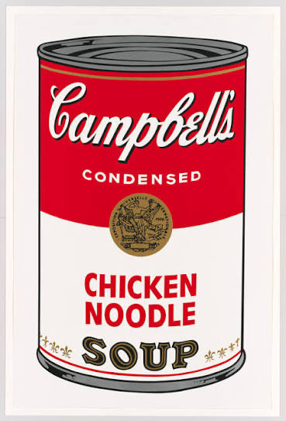 | 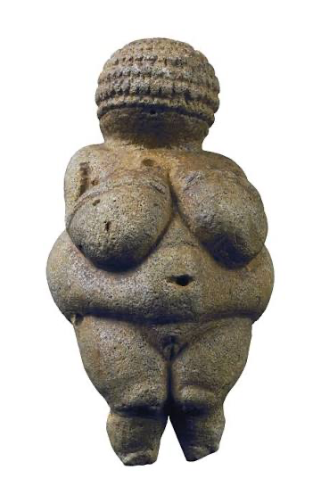
Table 3

What has changed? | Over time, the medium of art has changed from traditional painting on walls or canvas to newer forms like printing, photography, digital art, and video art. The subject matter has also changed. Older artworks often focused on religion, mythology, and important historical events, while modern and contemporary art often focuses on everyday life, celebrities, technology, and social issues. The values and ideas represented in art have changed because society has moved from focusing mainly on spiritual beliefs and powerful leaders to exploring personal identity, popular culture, and social problems.
What stayed the same? | Even though art has changed, artists still use elements and principles of design such as color, balance, contrast, line, and texture to communicate ideas. Art continues to represent the beliefs, values, and experiences of people from different time periods. Both older and newer artworks tell stories, express emotions, and reflect the culture and society of their time. Artists still use art to share messages and help people understand the world around them.

